

Windows Workflow Foundation

Hands-On Lab

Lab Manual
Lab 04 – Creating State Machine Workflows in C#

Information in this document, including URL and other Internet Web site references, is subject to change without notice. This document supports a preliminary release of software that may be changed substantially prior to final commercial release, and is the proprietary information of Microsoft Corporation.

This document is for informational purposes only. MICROSOFT MAKES NO WARRANTIES, EITHER EXPRESS OR IMPLIED, AS TO THE INFORMATION IN THIS DOCUMENT.

The entire risk of the use or the results from the use of this document remains with the user. Complying with all applicable copyright laws is the responsibility of the user. Without limiting the rights under copyright, no part of this document may be reproduced, stored in or introduced into a retrieval system, or transmitted in any form or by any means (electronic, mechanical, photocopying, recording, or otherwise), or for any purpose, without the express written permission of Microsoft Corporation.

Microsoft may have patents, patent applications, trademarks, copyrights, or other intellectual property rights covering subject matter in this document. Except as expressly provided in any written license agreement from Microsoft, the furnishing of this document does not give you any license to these patents, trademarks, copyrights, or other intellectual property.

Unless otherwise noted, the example companies, organizations, products, domain names, e-mail addresses, logos, people, places and events depicted herein are fictitious, and no association with any real company, organization, product, domain name, email address, logo, person, place or event is intended or should be inferred.

© 2005 Microsoft Corporation. All rights reserved.

Microsoft, MS-DOS, Windows, Windows NT, Windows Server, Visual C# and Visual Studio are either registered trademarks or trademarks of Microsoft Corporation in the United States and/or other countries.

The names of actual companies and products mentioned herein may be the trademarks of their respective owners.
Contents
Lab 04: Creating State Machine Workflows 1
Lab Objective 1
Exercise 1 – Create the Order State Machine Workflow 1
Task 1 – Create a new State Machine Workflow Project 2
Task 2 – Define the States for the Order State Machine Workflow 5
Task 3 – Define Workflow variables 9
Task 4 – Define the WaitingForOrderState 10
Task 5 – Define the OrderOpenState 17
Task 6 – Define the OrderProcessedState 23
Task 7 – Add the OrderApplication Project 30
Task 8 – Test the State Machine Workflow 31
Exercise 2 – Use the StateMachineTracking Service 33
Task 1 – Add a reference to the StateMachineTracking Service 33
Task 2 – Modify the code in the OrderApplication 34
Task 3 – Test the OrderApplication and State Machine Tracking 39
Lab Summary 40

Lab 04: Creating State Machine Workflows
Estimated time to complete this lab: 60 minutes
The project files for this lab are in the C:\Windows Workflow Foundation\Labs\Lab04 folder.

Lab Objective
The objective of this lab is to introduce another workflow authoring style known as State Machine Workflows. State Machine Workflows offer a flexible workflow creation style where the process is modeled as a state machine. Unlike a Sequential Workflow where the activities execute in a sequence, in a State Machine Workflow the activities execute based on external events. The state machine responds to an external event, does the required work and then moves to the next state.
After completing this lab, you will be able to:
- Author State Machine Workflows using the Visual Studio 2005 designer for Windows Workflow Foundation, referred to as the Visual Studio workflow designer in the remainder of this document.
- Utilize the State and SetState activities.
- Utilize the sample state machine tracking service to inspect and track the state of a workflow from the host application.

Exercise 1 – Create the Order State Machine Workflow
In this exercise, you will create a State Machine Workflow for managing an order. You can imagine an e-commerce application where an order might go through several states before it is completed. For our purposes, we’ll define the following four states:
- WaitingForOrderState
- OrderOpenState
- OrderProcessedState
- OrderCompletedState
In our order system there are also rules specifying what events can occur on an order depending on its current state. For example, an order that is open can be updated, processed, canceled, or shipped. However, an order that is processed, can only be updated or shipped, but cannot be canceled. As an event occurs, our State Machine Workflow can optionally transition the state for an order. For example, when an order is open and the OrderShipped event occurs, our State Machine Workflow will transition the completed state for the order. The states and transitions for our simple order State Machine Workflow are illustrated in the following diagram:

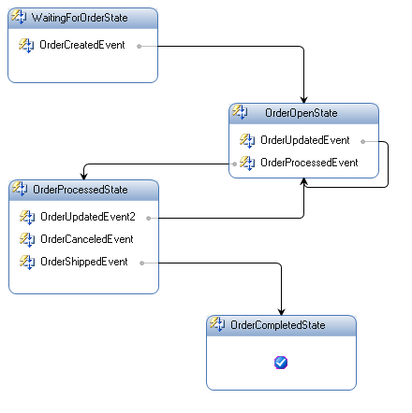

We will start creating the Order State Machine workflow by modeling the possible states for an order entity by using the State activity. Then we will specify the events that can occur with each state by using EventDriven activities and custom activities for the order events. In most cases when an order event occurs we will transition the state of the order using the SetState activity. Finally, after authoring our workflow we will test it using a pre-built Windows Forms host.

Task 1 – Create a new State Machine Workflow Project

- Open Visual Studio 2005 by going to the Start Menu | All Programs | Microsoft Visual Studio 2005 | Microsoft Visual Studio 2005
- In Visual Studio 2005, select the File | New | Project menu command.
- Visual Studio will display the New Project dialog window.
- In the New Project dialog window, expand Visual C# | Workflow in the Project Types tree on the left side.
- Select the template named State Machine Workflow Library and enter the following values for the name and location:

Name: OrderWorkflows

Location: C:\Windows Workflow Foundation\Labs\Lab04

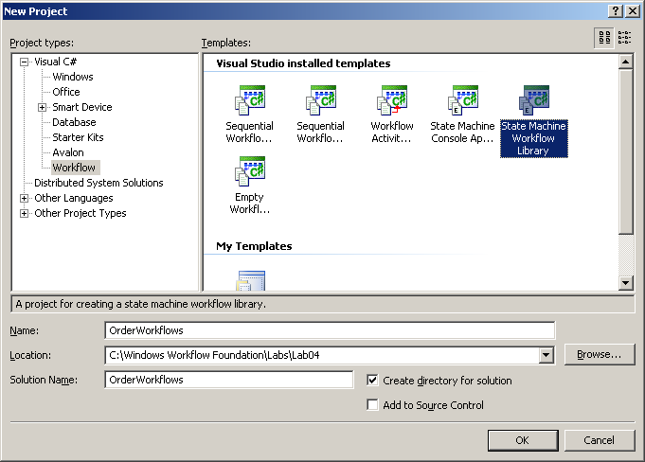

- You should now have a new solution and workflow project.
- Note also that under the project OrderWorkflows there is a file called Workflow1.cs added.

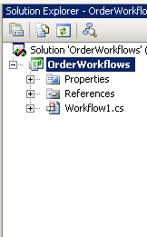

- Also you can see that the state machine designer is displayed.

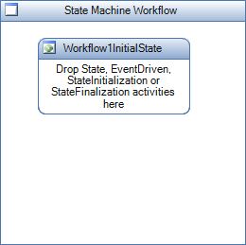

- We need a reference to the order services that will provide the events our state machine workflow uses. To add this reference, right-click on the OrderWorkflows project and select Add Reference….
- Select the Browse tab and browse to the following directory:

C:\Windows Workflow Foundation\Labs\Lab04\Resources\bin
- Select the OrderLocalServices.dll file and click OK as shown below:

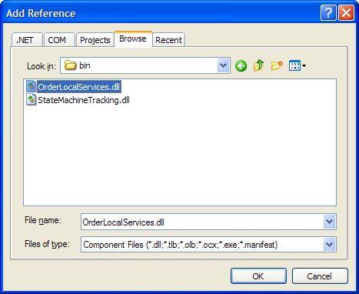

Task 2 – Define the States for the Order State Machine Workflow

We are now ready to define the workflow using the State Machine designer.

- Double click on the Workflow1.cs file. The Visual Studio workflow designer for the State Machine Workflow should be displayed.
  - The designer for the State Machine Workflow is a free form designer. You can move the state activity around and place it in any position you want on the drawing surface. As we build the state machine the transitions will also be drawn. Select the Workflow1InitialState in the diagram and try moving it around. You can drag it anywhere on the surface.
- In the Visual Studio workflow designer, select the View | Toolbox menu command to display the toolbox with available activities.
- Select the Workflow1InitialState activity in the Visual Studio workflow designer.
- In the properties window, change the (Name) property for the Workflow1InitialState activity to WaitingForOrderState.
- The Visual Studio workflow designer will now show a red exclamation point indicating there is an error with the workflow. Click on the exclamation point and select the error from the smart tag as shown below:

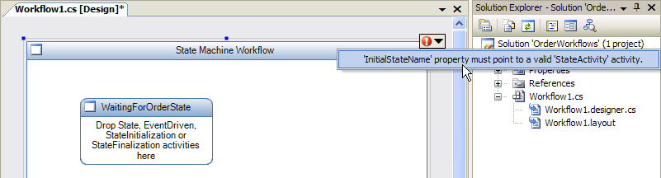

- We need to change the InitialStateName property. In the properties window, change the InitialStateName property for the State Machine Workflow to WaitingForOrderState.
- Add a State activity to the workflow definition by dragging and dropping it out of the toolbox.
- In the properties window, change the (Name) property for the new State activity to OrderOpenState.

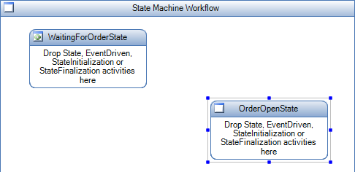

- Add a State activity to the workflow definition by dragging and dropping it out of the toolbox.
- In the properties window, change the (Name) property for the new State activity to OrderProcessedState. Your workflow definition should look like this:

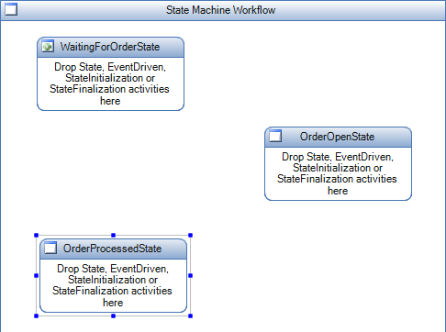

- Add a State activity to the workflow definition by dragging and dropping it out of the toolbox.
- In the properties window, change the (Name) property for the new State activity to OrderCompletedState. Your workflow definition should look like this:

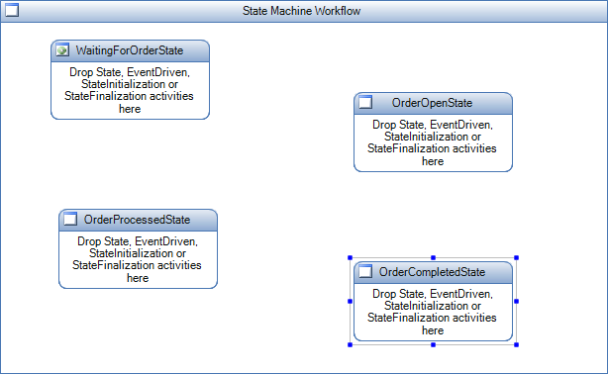

- Select the state machine workflow in the Visual Studio workflow designer by clicking on any empty space on the drawing surface.
- In the properties window, change the CompletedStateName property for the State Machine Workflow to OrderCompletedState. Your workflow definition should look like this:

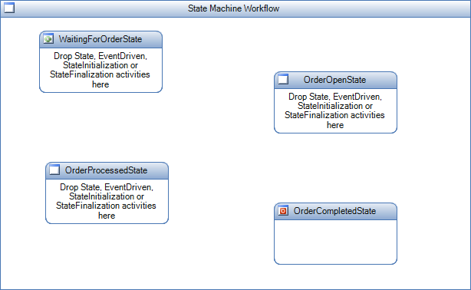

Task 3 – Define Workflow variables

- Before we configure the properties we will add a variable to which we will bind one of the properties of an activity in our workflow.
  - In order to add the variable right click on the file Workflow1.cs and select View Code.
  - Now add the following variable within the class Workflow1.

(Snippet: “Lab04 Ex01 Task3 Variable”)
private string orderCanceledError = "Order has been canceled";

public string OrderCanceledError
{
get { return orderCanceledError; }
}

Task 4 – Define the WaitingForOrderState

- Right click Workflow1.cs and select View Designer.
- Drag an EventDriven activity from the toolbox to the WaitingForOrderState.
- In the properties window, change the (Name) property for the new EventDriven activity to OrderCreatedEvent. Your workflow definition should look like this:

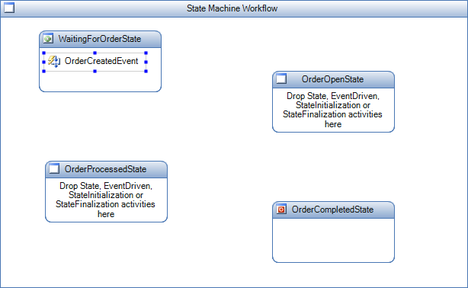

- Double click on the OrderCreatedEvent activity. The Visual Studio workflow designer will now show the contents of the EventDriven activity.

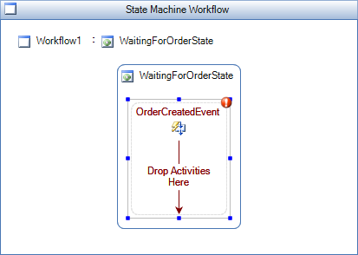

- Drag a HandleExternalEvent activity to the workflow definition from the toolbox into the OrderCreatedEvent EventDriven activity.

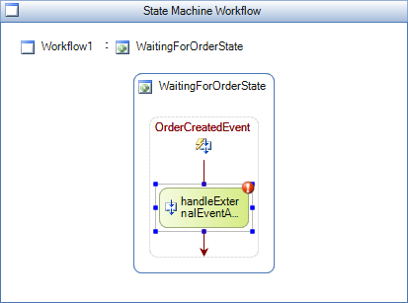

- Note that there is a validation error on the HandleExternalEvent activity. We need to configure the activity to make sure we can receive the OrderCreated event defined in the IOrderService interface. Click on the red exclamation point to find out that the InterfaceType and EventName properties need to be set.
- Click on the InterfaceType property in the properties window for handleExternalEventActivity1. Click on the button that is displayed next to the input box.

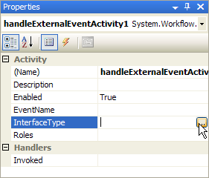

- The browse and select a .NET Type dialog is displayed. Expand the Referenced Assemblies and select the OrderLocalServices assembly. The IOrderService interface will be displayed. Select that interface and click OK.
- Select OrderCreated from the drop down for the EventName property.

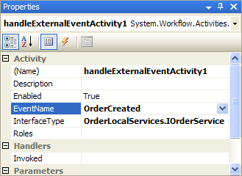

We have now configured the HandleExternalEvent activity to receive the OrderCreated Event from the IOrderService interface.
- Once you have selected the OrderCreated event type you will notice that there are 2 more properties that get added. The e property and the Sender property.
- For the e property select the property and click the ellipsis button next to it to bring up the activity binding interface. Select the Bind to a new member tab as shown below:

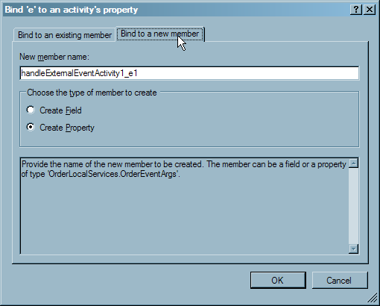
- Enter OrderEvtArgs in the New member name box and click OK.
- For the sender property, click the ellipsis button and use the activity binding interface to bind sender to a new member variable called OrderSender as shown above.

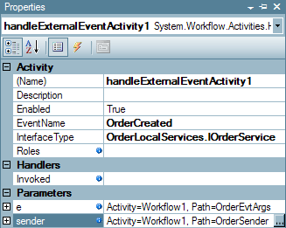

- Add a SetState activity to the workflow definition by dragging and dropping it out of the toolbox into the OrderCreatedEvent EventDriven activity, below the HandleExternalEvent activity.
- With the new SetState activity selected, in the properties window change the TargetStateName property to OrderOpenState. Your workflow definition should look like this:

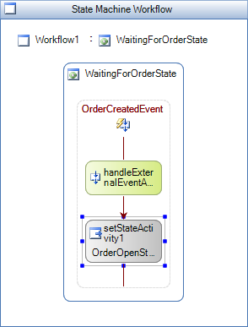

- Navigate back to the State view in the State Machine Workflow by clicking on the Workflow1 link in the Visual Studio workflow designer. Alternatively, you can use the Document Outline tool window to view the entire workflow as a hierarchical tree. Open the Document Outline window by selecting the View | Other Windows | Document Outline menu item.

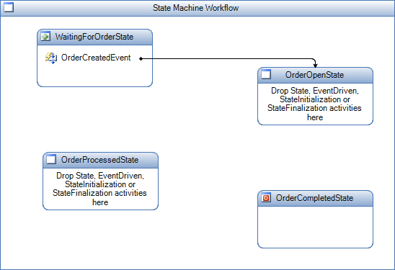

NOTE: In the following tasks we will be adding more event handlers and state transitions. All the events come from the same source and use the same arguments, so we are going to copy and paste the EventDriven activities and change some of the properties, rather than create them all over again.

In summary what we did in Task 4 is as follows (this is just a summary, don’t follow these steps):
- Dropped an event driven activity inside the State activity.
- Double clicked on the EventDriven activity to look at the details of the EventDriven activity.
- Dropped a HandleExternalEvent activity inside the event driven activity.
- Configured the HandleExternalEvent activity -
  - Configured the interface and the event that can be received.
  - Configured the fields on the event payload by binding them to workflow variables.
- Defined a SetState activity and defined a transition to the next state.

The configuration of the OrderOpenState and the OrderProcessedState is similar to the WaitingForOrderState.

In task 5 we will configure the OrderOpenState to receive the following events:
- OrderUpdatedEvent – Transition back to the OrderOpenState.
- OrderProcessedEvent – Transition to the OrderProcessedState.

In task 6 we will configure the OrderProcessedState to receive the following events:
- OrderUpdatedEvent – Transition back to the OrderOpenState.
- OrderCanceledEvent – We will Terminate the workflow as a result of this event.
- OrderShippedEvent – Transition to the OrderCompletedState.

Task 5 – Define the OrderOpenState

Define the OrderUpdated Event

- In the design view for the state machine workflow, right-click the OrderCreatedEvent from task 4 in the WaitingForOrderState and select Copy.
- Select the OrderOpenState, right-click and select Paste. This will automatically take you to the design view for the new EventDriven activity you pasted.
- Change the (Name) property for eventDrivenActivity1 to OrderUpdatedEvent.
- Select the HandleExternalEvent activity and change the EventName property to OrderUpdated.
- Set the property e to Workflow1.OrderEvtArgs by clicking the ellipsis button next to it and selecting the OrderEvtArgs member as shown below. Click OK to close the window and bind the property.

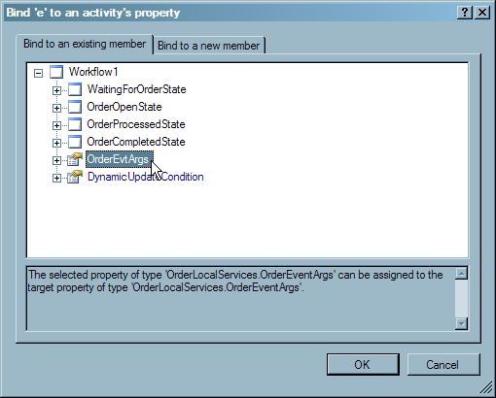
- Click on the ellipsis button next to sender and use the activity binding interface to bind it to Workflow1.OrderSender. The properties window should now look like this:

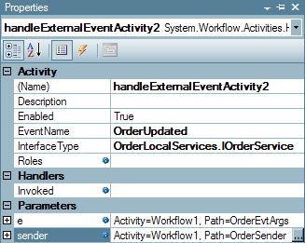

- We are going to leave the target state of the SetState activity set to OrderOpenState.
- Navigate back to the State view in the State Machine Workflow by clicking on the State Machine Workflow link in the Visual Studio workflow designer. Alternatively, you can use the Document Outline tool window to view the entire workflow as a hierarchical tree. Open the Document Outline window by selecting the View | Other Windows | Document Outline menu item.

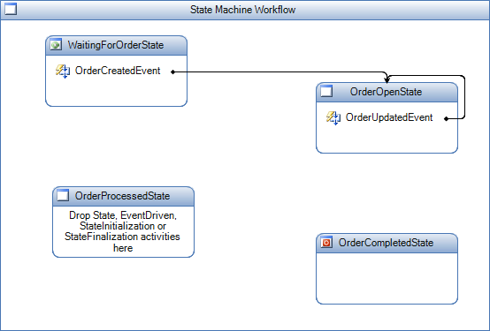

Define the OrderProcessed Event

- In the design view for the state machine workflow, right-click the OrderCreatedEvent from task 4 in the WaitingForOrderState and select Copy.
- Select the OrderOpenState, right-click and select Paste. This will automatically take you to the design view for the new EventDriven activity you pasted.
- Change the (Name) property for eventDrivenActivity1 to OrderProcessedEvent.
- Select the HandleExternalEvent activity and change the EventName property to OrderProcessed.
- Set the property e to Workflow1.OrderEvtArgs and sender to Workflow1.OrderSender using the activity binding interface. The properties window should now look like this:

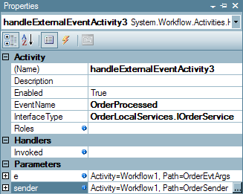

- Navigate back to the State view in the State Machine Workflow by clicking on the Workflow1 link in the Visual Studio workflow designer.

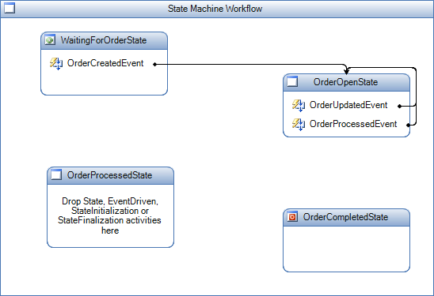

- As you can see, the order processed event currently sets the state to OrderOpenState. We want it to link to OrderProcessedState instead. We could do this by manually setting the TargetStateName property on the SetState activity or we can use the drag and drop in the workflow designer. Select the OrderProcessedEvent connector as shown below.

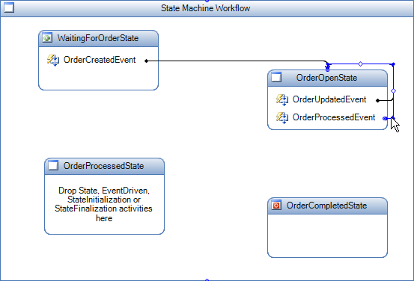
- The connector currently terminates at the top of the OrderOpenState. Move your mouse cursor over the point where it terminates and the cursor will change to a square target. Click and hold to drag the connector to the top of the OrderProcessedState as shown below.

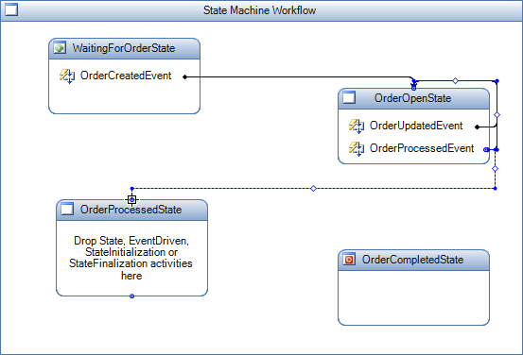
- After you release the mouse button over the top of the OrderProcessedState, click on the blank space in the workflow designer and your workflow should look like this.

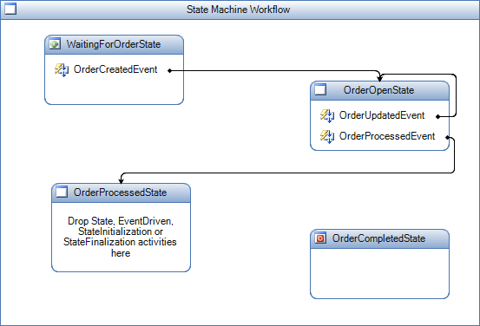

Task 6 – Define the OrderProcessedState

Define the OrderUpdated Event

- In the design view for the State Machine Workflow, right-click the OrderUpdatedEvent from task 7 in the OrderOpenState and select Copy.
- Select the OrderProcessedState, right-click and select Paste. This will automatically take you to the design view for the new EventDriven activity you pasted.
- Change the (Name) property for eventDrivenActivity1 to OrderUpdatedEvent2 (as we have already defined an OrderUpdatedEvent in the previous task).
- That is it, as all the activities are configured correctly from task 5.
- Navigate back to the State view in the State Machine Workflow by clicking on the Workflow1 link in the Visual Studio workflow designer.

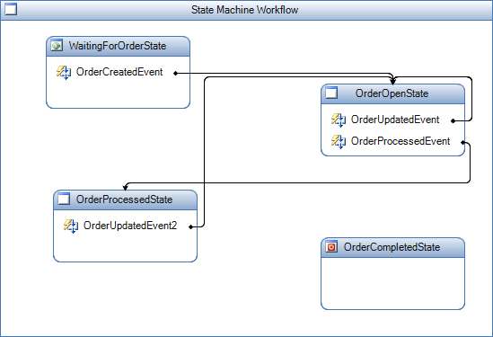

Define the OrderCanceled Event

- In the design view for the State Machine Workflow, right-click the OrderCreatedEvent from task 6 in the WaitingForOrderState and select Copy.
- Select the OrderProcessedState, right-click and select Paste. This will automatically take you to the design view for the new EventDriven activity you pasted.
- Change the (Name) property for eventDrivenActivity1 to OrderCanceledEvent.
- Select the HandleExternalEvent activity and change the EventName property to OrderCanceled.
- Set the property e to Workflow1.OrderEvtArgs and sender to Workflow1.OrderSender using the activity binding interface. The properties window should now look like this:

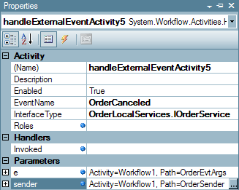

- Select the SetState activity, right-click on it and select Delete.
- Add a Terminate activity to the workflow definition by dragging and dropping it out of the toolbox into the OrderCanceledEvent EventDriven activity, below the HandleExternalEvent activity. When we receive the cancel event we need to terminate the workflow. The terminate activity will help us do that.
- With the new Terminate activity selected, in the properties window change the Error property to Workflow1.OrderCanceledError using the activity binding interface.

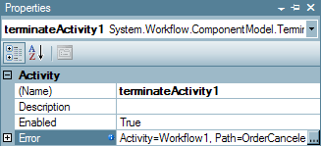

The workflow should now look like the following:

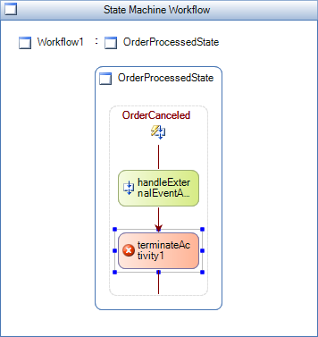

- Navigate back to the State view in the state machine workflow by clicking on the Workflow1 link in the Visual Studio workflow designer.

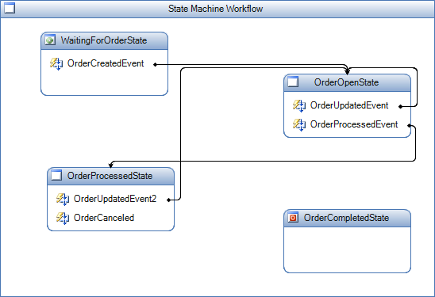

Define the OrderShipped Event

- In the design view for the State Machine Workflow, right-click the OrderCreatedEvent from task 4 in the WaitingForOrderState and select Copy.
- Select the OrderProcessedState, right-click and select Paste. This will automatically take you to the design view for the new EventDriven activity you pasted.
- Change the (Name) property for eventDrivenActivity1 to OrderShippedEvent.
- Select the HandleExternalEvent activity and change the EventName property to OrderShipped.
- Set the property e to Workflow1.OrderEvtArgs and sender to Workflow1.OrderSender using the activity binding interface. The properties window should now look like this:

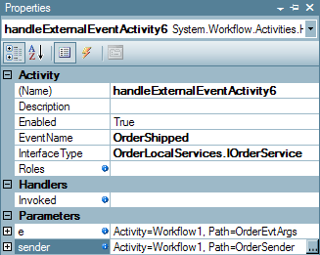

- We need to make an Invoked handler for demonstration purposes. Do this by entering OrderShipped_Invoked in the Invoked property. When you press Enter, you will be taken to the handler in the code view. Put a break point on the handler then switch back to the designer to complete this task.
- Select the SetState activity set and change the TargetStateName property to OrderCompletedState as shown below:

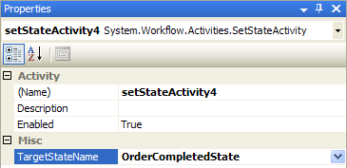

- Navigate back to the State view in the State Machine Workflow by clicking on the Workflow1 link in the Visual Studio workflow designer.

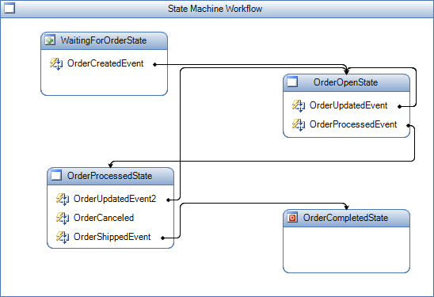

- We need to make another Invoked handler for demonstration purposes.
- Double click on the OrderCreatedEvent in the WaitingForOrderState state.
- Select the HandleExternalEventActivity and view its properties.
- Enter OrderCreated_Invoked in the Invoked property. When you press Enter, you will be taken to the handler in the code view. Put a break point on the handler.

Task 7 – Add the OrderApplication Project

In the previous tasks, we were designing the workflow for order management. We now need to create a host application that will call the workflow. The host application will also send the appropriate events to the workflow instance. For our host application we will create a Windows Forms application that will provide options for sending all events to the workflows. The form will also display the order and the latest status of the workflow associated with the order. The form will look like this:

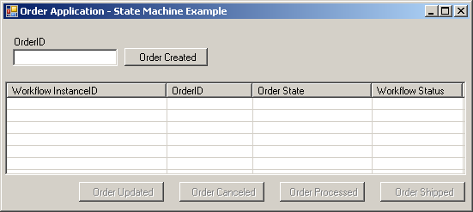

You may notice that the buttons on the form correspond to the events we handle in our workflow.
This windows forms project has already been created; all you need to do is to include the project in your application by following the steps below:

- Using Windows Explorer navigate to the following directory:

C:\Windows Workflow Foundation\Labs\Lab04\Resources
- Copy the OrderApplication directory to the following location:

C:\Windows Workflow Foundation\Labs\Lab04\OrderWorkflows
- In Visual Studio 2005, in the OrderWorkflows solution, add the OrderApplication project into the solution by selecting the File | Add | Existing Project menu item.
- Enter or browse to the following OrderApplication.csproj file located in the following directory:

C:\Windows Workflow Foundation\Labs\Lab04\OrderWorkflows\OrderApplication
- Using the Solution Explorer tool window, select the OrderApplication, expand the References folder and remove the OrderLocalServices and OrderWorkflows references.
- Add reference to the OrderLocalServices.dll in C:\Windows Workflow Foundation\Labs\Lab04\Resources\bin. (If you need help adding this reference, refer to steps 9-11 in task 1.)
- Add a reference to the OrderWorkflows project by right-clicking on the OrderApplication project in the solution explorer selecting Add Reference…; selecting the Projects tab in the dialog and clicking OK (as there is only one project to select and it will already be selected).

Task 8 – Test the State Machine Workflow

- Right-click on the OrderApplication project in the solution explorer and select Set as Startup Project.
- Compile and run the OrderWorkflows project under the Microsoft Visual Studio debugger by pressing F5 or selecting the Debug | Start Debugging menu command.
- The OrderApplication then starts and displays a simple Windows Form for raising the Order Events.
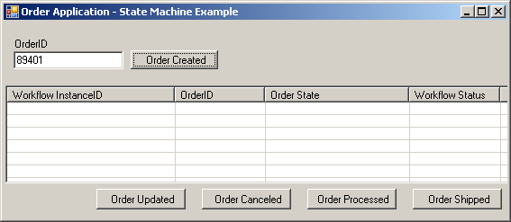
- Using the OrderApplication, enter a value for the OrderId field and click the Order Created button to create a new instance of the Order State Machine Workflow and raise an OrderCreated event into the new workflow instance. Information about the new workflow instance will be added to the ListView on this form.

NOTE: The Order State column will always be empty during this exercise. We will add functionality to this form in Exercise 2 to provide the Order State

- Visual Studio 2005 will then break into debug mode for the OrderCreated_Invoked method. Continue execution of the workflow by selecting the Debug | Continue menu item.

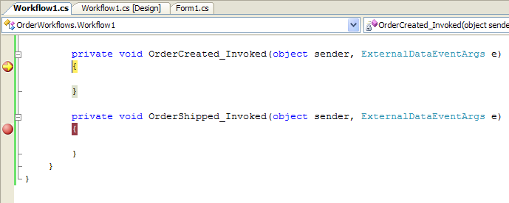

- Using the OrderApplication, select the new item in the ListView and click on the Order Processed button.
- Click on the Order Shipped button on the OrderApplication.

NOTE: If you click the buttons on the Order Application out of order and raise an event that is not expected by the State Machine Workflow, then you will either see an exception or the workflow will do nothing. We will learn how to inspect a State Machine Workflow’s current state in Exercise 2.

9. Visual Studio 2005 will then go into debug mode for the OrderShipped_Invoked method. Continue execution of the workflow by selecting the Debug | Continue menu item.
- Finally, close the OrderApplication to stop debugging.

Exercise 2 – Use the StateMachineTracking Service

In Exercise 1 you learned how to author a state machine workflow. We tested the workflow with a simple Windows Forms application, called the OrderApplication, which allowed us to raise events for an order so they could be handled by the workflow. However, you might have noticed that the OrderApplication allowed us to raise any order event regardless of the state of the order workflow and the events the workflow could receive.

In this exercise we’re going to modify a simple version of the OrderApplication to use a sample runtime service we are calling the StateMachineTracking service. The StateMachineTracking service allows a host to inspect the state of a state machine workflow and receive key events during its lifetime. For example, using the StateMachineTracking service a host application can receive a StateChanged event whenever the workflow performs a state transition using the SetState activity. We will use the StateMachineTracking service to enhance the OrderApplication to display the current state for each order record in the ListView. We will also customize the OrderApplication so that a user can only raise order events that are valid based on the order’s current state. For example, if an order is in a processed state, then the OrderApplication will only allow the user to raise an OrderShipped or an OrderUpdated event.

Task 1 – Add a reference to the StateMachineTracking Service

- Before we can begin using the StateMachineTracking service, we also need to add a reference to the StateMachineTracking.dll. Right click on the References folder for the OrderApplication in Solution Explorer and selecting Add Reference from the context menu.
- In the Add Reference dialog window, select the Browse tab.
- Enter or browse to the StateMachineTracking.dll assembly located in the following directory:

C:\Windows Workflow Foundation\Labs\Lab04\Resources\bin
- Press the OK button to close the Add Reference dialog window and add the new reference.

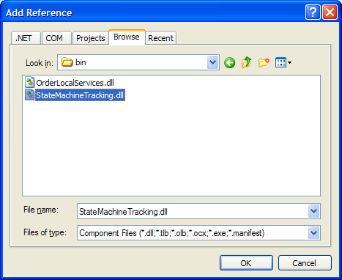

Task 2 – Modify the code in the OrderApplication

- Right click on Form1.cs in Solution Explorer and select View Code from the context menu.
- Add a using statement for the StateMachineTracking namespace at the top of the code file:
using StateMachineTracking;
- Add a member-level variable in the Form1 class for holding a reference to the StateMachineTrackingService:
private StateMachineTrackingService stateMachineTrackingService;
- Add another member-level variable in the Form1 class for managing a generic dictionary of StateMachineInstance objects:
private Dictionary<string, StateMachineInstance> stateMachineInstances;
- Modify the code in the Form_Load method to create a new instance of a generic dictionary for the type StateMachineInstance class and assign the new list to our member-level variable. We also need to disable all of the buttons that can be used to raise events. Add this code before the call to StartWorkflowRuntime().
this.stateMachineInstances = new Dictionary<string, StateMachineInstance>(); this.DisableButtons();
- Modify the code in the StartWorkflowRuntime method to create a new instance of the StateMachineTrackingService class and add the new instance to the workflow runtime.
private void StartWorkflowRuntime()
{
// Create a new Workflow Runtime for this application
_WFRuntime = new WorkflowRuntime();

// Create EventHandlers for the WorkflowRuntime
_WFRuntime.WorkflowTerminated += new EventHandler<WorkflowTerminatedEventArgs>(WorkflowRuntime_WorkflowTerminated);
_WFRuntime.WorkflowCompleted += new EventHandler<WorkflowCompletedEventArgs>(WorkflowRuntime_WorkflowCompleted);

stateMachineTrackingService = new StateMachineTrackingService(_WFRuntime);

// Start the Workflow services
_WFRuntime.StartRuntime();

// Add a new instance of the OrderService to the runtime
ExternalDataExchangeService dataService = new ExternalDataExchangeService();
_WFRuntime.AddService(dataService);
_OrderService = new OrderLocalServices.OrderService();
dataService.AddService(_OrderService);
}
- Modify the code in the StartOrderWorkflow method to use the StateMachineTracking Service. Delete the code that starts a new workflow. Instead, we need to call the StartWorkflow method on the StateMachineTracking Service so it can intercept the events that occur from the workflow. We also need to hook onto the StateChanged event from the StateMachineInstance. Finally, we will add the StateMachineInstance object to our member-level list.

(Snippet: “Lab04 Ex02 Task2 StartOrderWorkflow”)
private System.Guid StartOrderWorkflow(string orderId)
{
// Create a new GUID for the WorkflowInstanceId
System.Guid WorkflowInstanceId = System.Guid.NewGuid();

StateMachineInstance stateMachineInstance =
stateMachineTrackingService.RegisterInstance(
typeof(OrderWorkflows.Workflow1), WorkflowInstanceId);
stateMachineInstance.StateChanged +=
new EventHandler<ActivityEventArgs>(StateMachineInstance_StateChanged);

stateMachineInstance.StartWorkflow();
stateMachineInstances.Add(WorkflowInstanceId.ToString(),
stateMachineInstance);

return workflowInstanceId;
}
- Create a helper method named GetSelectedStateMachineInstance. This method will get the WorkflowInstanceId for the selected record in the ListView and lookup the corresponding StateMachineInstance object from our member-level list.

(Snippet: “Lab04 Ex02 Task2 GetSelectedStateMachine”)

private StateMachineInstance GetSelectedStateMachineInstance()
{
// Get the WorkflowInstanceId for the selected item
string workflowInstanceId = this.lstvwOrders.SelectedItems[0].Text;

// Return the StateMachineInstance object
return stateMachineInstances[workflowInstanceId];
}
- Create the EnableButtons method to enable the buttons on this form based on the messages or events allowed into the state machine workflow instance. First, we will check and make sure that a record is selected in the ListView; then we will check to make sure that the workflow is still running. Finally we shall determine whether the workflow accepts a specific message (such as OrderShipped). This functionality is provided through the StateMachineInstance class included with the StateMachineTrackingService.

(Snippet: “Lab04 Ex02 Task2 EnableButtons”)
private void EnableButtons()
{
if (this.lstvwOrders.SelectedItems.Count == 0)
{
return;
}

string workflowStatus =
this.lstvwOrders.SelectedItems[0].SubItems[3].Text;

if ((workflowStatus.Equals("Completed"))
|| (workflowStatus.Equals("Terminated")))
{
return;
}

// Return the StateMachineInstance object
StateMachineInstance stateMachineInstance =
this.GetSelectedStateMachineInstance();

if (stateMachineInstance.CurrentState == null)
{
return;
}

if (stateMachineInstance.MessagesAllowed.Contains("OrderCanceled"))
this.btnOrderCanceled.Enabled = true;

if (stateMachineInstance.MessagesAllowed.Contains("OrderProcessed"))
this.btnOrderProcessed.Enabled = true;

if (stateMachineInstance.MessagesAllowed.Contains("OrderShipped"))
this.btnOrderShipped.Enabled = true;

if (stateMachineInstance.MessagesAllowed.Contains("OrderUpdated"))
this.btnOrderUpdated.Enabled = true;

}

- Create a helper method called DisableButtons.

(Snippet: “Lab04 Ex02 Task2 DisableButtons”)
private void DisableButtons()
{
this.btnOrderCanceled.Enabled = false;
this.btnOrderProcessed.Enabled = false;
this.btnOrderShipped.Enabled = false;
this.btnOrderUpdated.Enabled = false;
}
- Modify the code in the btnOrderEvent_Click method to disable all of the buttons on the form before raising an event. Add the line of code highlighted in gray.
private void btnOrderEvent_Click(object sender, EventArgs e)
{
// Get the Name for the button that was clicked
string strButtonName = ((Button)sender).Name;

// Get the WorkflowInstanceId for the selected order
System.Guid WorkflowInstanceId = this.GetSelectedWorkflowInstanceID();

// Get the OrderID for the selected order
string strOrderId = this.GetSelectedOrderId();

this.DisableButtons();

switch (strButtonName)

- Create an UpdateButtonStatus method to disable and then enable the buttons on this form. This method needs to use a delegate to invoke itself if the code is executing on a different thread than the thread used to create the button controls originally.

(Snippet: “Lab04 Ex02 Task2 UpdateButtonStatus”)

private void UpdateButtonStatus()
{
if (this.InvokeRequired)
{
UpdateButtonStatusDelegate updateButtonStatus =
new UpdateButtonStatusDelegate(this.UpdateButtonStatus);
this.Invoke(updateButtonStatus);
}
else
{
DisableButtons();
EnableButtons();
}
}
- Create the StateMachineInstance_StateChanged method to handle the StateChanged event that occurs whenever the state in our Order State Machine Workflow is changed. We will update the record in the ListView and the status of the buttons on the form based on the current state unless we’re in the completed state.

(Snippet: “Lab04 Ex02 Task2 StateChanged”)
protected void StateMachineInstance_StateChanged(object sender,
ActivityEventArgs e)
{
StateMachineInstance stateMachineInstance =
(StateMachineInstance)sender;

if (e.QualifiedId != stateMachineInstance.CompletedState)
{
WorkflowInstance workflowInstance =
stateMachineInstance.WorkflowInstance;

this.UpdateListItem(workflowInstance,
e.QualifiedId.ToString(), "Running");
this.UpdateButtonStatus();
}
}
- Modify the code in the lstvwOrders_ItemSelectionChanged method to update the status for the buttons on this form when a record is selected in the ListView. We will disable all of the buttons if the item is deselected.

(Snippet: “Lab04 Ex02 Task2 ItemSelectionChanged”)
private void lstvwOrders_ItemSelectionChanged(object sender,
ListViewItemSelectionChangedEventArgs e)
{
if (e.Item.Selected)
{
this.UpdateButtonStatus();
}
else
{
this.DisableButtons();
}
}

Task 3 – Test the OrderApplication and State Machine Tracking

- Remove the breakpoints we inserted in the previous exercise by selecting Debug | Delete All Breakpoints from the menu.
- Compile and run the solution under the Visual Studio debugger by pressing F5 or selecting the Debug | Start Debugging menu command.
- You will then see the OrderApplication.
- Enter a value for the OrderId field and press the Order Created button to create a new instance of the workflow and raise an OrderCreated event. You can repeat this process to create several instances of the Order State Machine Workflow.
- As you create the Orders, you should see the Order State value for each record quickly change from WaitingForOrderState to OrderOpenState.
- When you select a record, you should notice that the Order Updated and Order Processed buttons are enabled.
- Press the Order Processed button to raise an OrderProcessed event to the workflow.
- After a few seconds, you should notice that the Order State has changed to OrderProcessState and now when the record is selected only the Order Updated, Order Shipped and Order Canceled buttons are enabled.

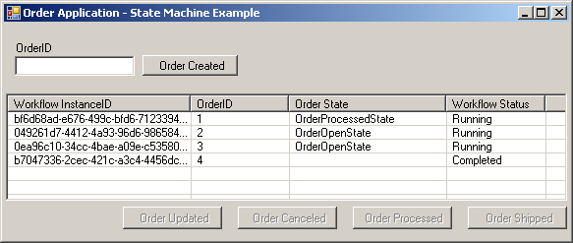

Lab Summary

In this lab you performed the following exercises:

- Create the Order State Machine Workflow.
- Use the StateMachineTracking Service.

In this lab, you learned how to model a State Machine Workflow in Windows Workflow Foundation using the Visual Studio workflow designer while utilizing the State, SetState, and EventHandler activities. You also learned how to interact with a State Machine Workflow from the host application using the sample StateMachineTracking service.

